| **id** | **first_name** | **last_name** | **department** | **education** | **salary** |
| --- | --- | --- | --- | --- | --- |
| 376 | Gary | Stokes | Accounting | Master | 56760 |
| 377 | Lorenzo | Cortez | Accounting | Doctorate | 74127 |
| 378 | Roberta | Mcgee | Administration | Primary | 23987 |
| 379 | Myrtle | Munoz | Administration | Primary | 31079 |
| 380 | Molly | Walker | Administration | Primary | 20725 |
| 381 | Maria | Simmons | Administration | Secondary | 39723 |
| 382 | Muriel | Hernandez | Administration | Bachelor | 58555 |
| 383 | Andres | Watson | BI | Bachelor | 56834 |
| 384 | Wayne | Leonard | BI | Master | 65180 |
| 385 | Julius | Poole | BI | Master | 55842 |
| 386 | Louis | Baker | Facilities | Primary | 31158 |
| 387 | Sandra | Wright | HR | Primary | 24082 |
| 388 | Jenny | Peterson | HR | Secondary | 31098 |
| 389 | Ellis | Hodges | HR | Secondary | 38128 |
| 390 | Larry | Jacobs | IT | Secondary | 33544 |
| 391 | Milton | Pratt | IT | Secondary | 35476 |
| 392 | Marvin | Gilbert | IT | Bachelor | 41147 |
| 393 | Geoffrey | Montgomery | IT | Bachelor | 47757 |
| 394 | Anne | Mann | IT | Master | 54863 |
| 395 | Marjorie | Malone | Legal | Bachelor | 45149 |
| 396 | Erika | Fuller | Legal | Master | 53391 |
| 397 | Guadalupe | Shaw | Legal | Doctorate | 62994 |
| 398 | Benny | Scott | Legal | Doctorate | 77474 |
| 399 | Geraldine | Stewart | Management | Doctorate | 79689 |
| 400 | Sylvia | Ingram | Management | Doctorate | 75944 |

Table name: google_salaries

Select all the columns where employees are getting salary more than 50000

Ans:

select * from google_salaries

where salary >5000;

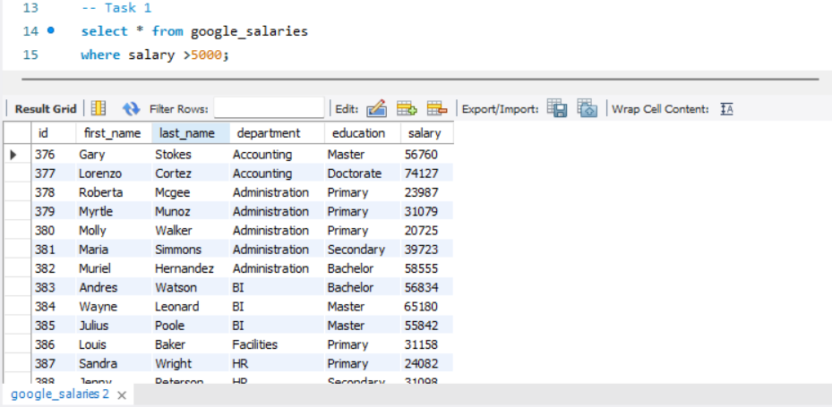

Select first name, department and education where employees first name are started with ‘Ma’

Ans:

Select first_name, department, education

from google_salaries

where first_name like "Ma%";

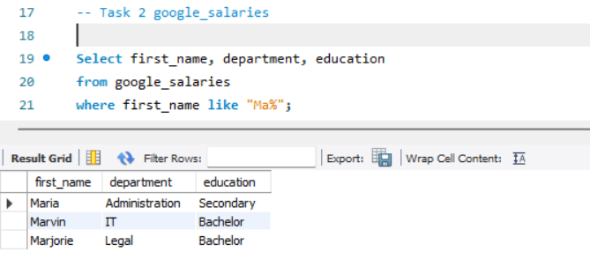

Select unique department.

Ans:

select distinct department

from google_salaries;

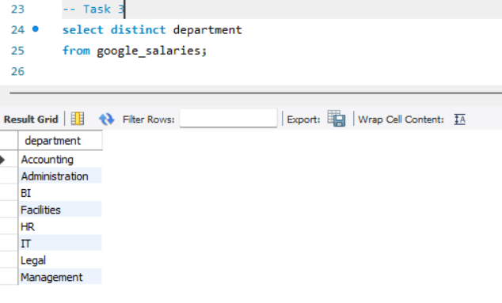

Make a group by education and present the total salary for every group

Ans:

select education, sum(salary) as Total_salary

from google_salaries

group by education;

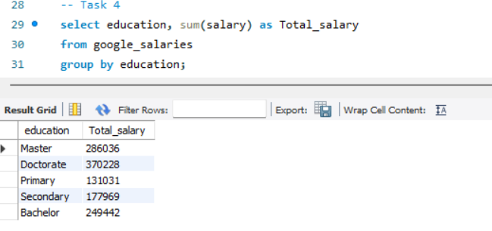 Bottom of Form